Nginx setup 80:8080 port

Step 1:- Ami

creater instance to ec2-user(linux)

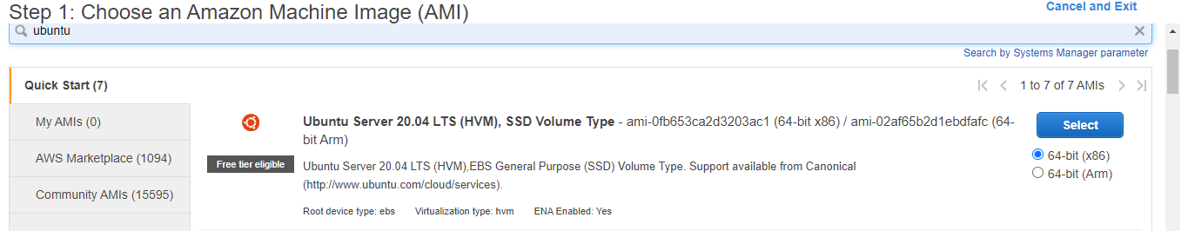

Then change the security group

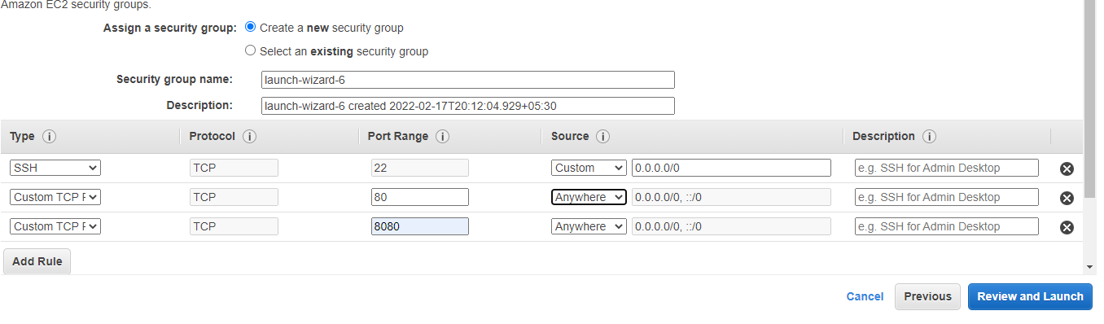

Step 2 : launch instance

And using command

* apt install update -y
* apt install nginx

root directory:- /usr/share/nginx/index.html

configuration file:- /etc/nginx/nginx.configuration

go to directory

cd /etc/nginx/conf.d/------------and create file

vim demo.conf

server {

listen 8080;

listen [::]:8080;

server_name _;

root /var/www;

# Load configuration files for the default server block.

include /etc/nginx/default.d/*.conf;

error_page 404 /404.html;

location = /404.html {

}

error_page 500 502 503 504 /50x.html;

location = /50x.html {

}

}

:wq

Now go to the

cd/var/www/html/

and create

echo "hello world" > /var/www/html/index.html

systemctl restart nginx

systemctl status nginx

systemc enable nginx

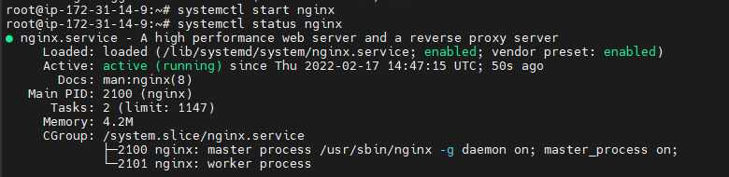

Now go to the chrome --------------

And put the ip-address of your instance 3.145.72.97:8080

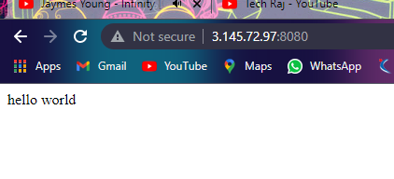

Also put only ip –address 3.145.72.97

